QUESTION 2 Notes

Question 2 A
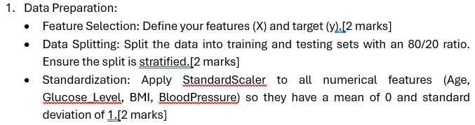
Data Preparation : Feature and Target Selection
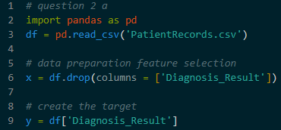
- Target(y) – This is the outcome to predict. In this dataset, It is the Diagnosis_Result column
- Features(x) – These are the input variables used to make the prediction, such as Age, Glucose Level, BMI, and Blood Pressure

Data Splitting (Training vs Testing)
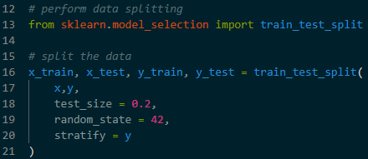
- Training Set (80%) – To teach the model
- Testing Set (20%) – To check the model’s accuracy
- Stratified Sampling – This ensures that the percentage of positive and negative diagnosis is the same in both the training and testing sets. This prevents the model from being biased toward one result
- Random State – Setting a seed, so that the split is the same every time the code runs

Standardization
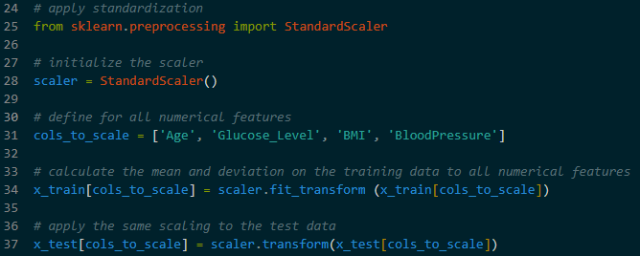
- Using StandardScaler to shift the mean of each feature to 0 and the standard deviation to 1
- This ensures that one feature does not dominate others simply because it’s numbers are larger
- Using fit_transform on the training data to calculate the scaling rules, and only transform on the test data to apply those same rules without leaking test information into the training phase

Question 2 B
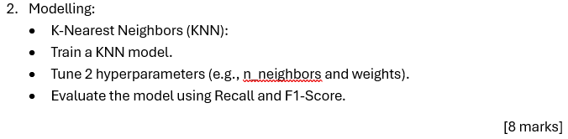
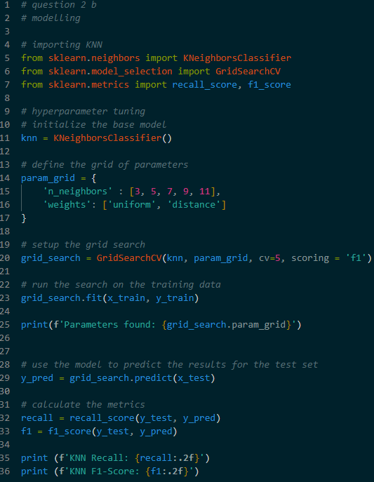
- KNN makes predictions by finding the most similar historical records in the training data
- Hyperparameter Tuning – Using GridSearchCV to find the best settings for the model
  - n_neighbors : The number of similar patients to check
  - weights : Decides if closer neighbors should have more influence on the final prediction
- Fitting – The model looks at the patterns between the features and the target in the training set

Question 2 C
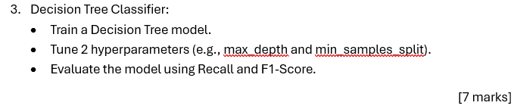
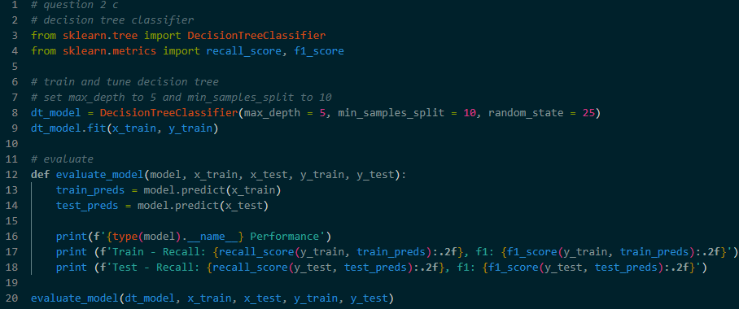
- A decision tree creates a series of Yes / No questions to reach a conclusion
- Hyperparameter Tuning : max_depth limits how many question the tree can ask.
  - This prevent the model from becoming too complex and memorizing the training data
- min_samples_split : The minimum amount of data required to create a new branch in the tree
Evaluation
- In medical diagnosis, simply checking Accuracy is not enough. Need to use specific metrics to measure reliability:
  - Recall – Measures the ability of the model to find all positive cases. In medicine, high Recall is vital because missing a sick patient (a False Negative) is dangerous
  - F1-Score – This provides a single scores that balance the accuracy of positive predictions and the ability to find all positive cases

